# ICT SBA

6A Jennifer Ko (8)

# Table Of Content:

## [Introduction](#_Introduction:)---------------------------------------------------------P.3

## [Pros and Cons of the design](#_Pro and Cons of the design)---------------------------------P.4-P.7

### [Pros](#_Pros)-----------------------------------------------------P.4-P.6

### [Cons](#_Cons)----------------------------------------------------P.7

## [Multimedia Element](#_Multimedia Element:)----------------------------------------------P.8

**[Key Factors of a Good Website](#_Key Factors of a Good Website)---------------------------P.9-P.10**

* **[Clarity](#_Clarity)------------------------------------------------P.9**
* **[Usability](#_Usability)----------------------------------------------P.9-P.10**
* **[Accessibility](#_Accessibility)------------------------------------------P.10**
* **[Navigation](#_Navigation)--------------------------------------------P.10**

**[Improvement of website](#_Improvement of website)----------------------------------P.11-P.12**

* **[Function](#_Function)-----------------------------------------------P.11**
* **[Search bar](#_Search bar)--------------------------------------------P.11**
* **[Site map](#_Site map)-----------------------------------------------P.11**
* **[Bugs](#_Bugs)----------------------------------------------P.11-P.12**

## [Test and evaluation](#_Test and Evaluation)----------------------------------------P.13-P.14

* **[Function](#_Function_1)------------------------------------------------P.13**
* **[Search bar](#_Search Bar)----------------------------------------------P.13**
* **[Site map](#_Site map_1)------------------------------------------------P.14**

# Introduction:

### Improvement in website

After several testing and evaluation,the web page of the online bookstore have been improved in different ways.The web page is now more user-friendly and functioned well.Validation in different aspect is also functioned.It can prevent users enter wrong information.

In general,the website is designed for customers to place order.First, customers click the book cover to view more details of the book.Then,customers can enter the quantity needed in text box and click “Shopping cart” to establish the order.Finally,they can save the selections in the shopping cart and continue surfing or they can checkout to know the total of the books.In addition,they can clear the shopping cart by clicking “Clear”.

# Pros and Cons of the design:

### Pros

1.Layout:The layout of the website is clear and tidy.User can easily know the instruction such as the instruction “**Click On The Book For More!**”.It can make the website more user-friendly with clear instruction.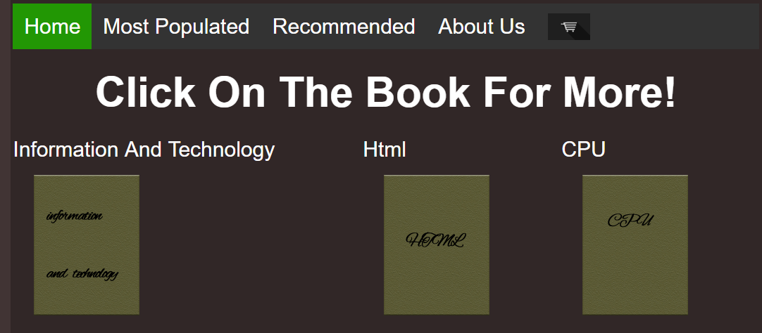

The instruction “Click On The Book For More!”

In addition,some forms that require users’ input also have instruction as placeholders.It can make the users know what value should they enter and avoid users being puzzled or enter the wrong value.

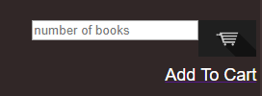

Placeholder for user enter number

Furthermore,The scrolling text will show the most updated information of sales and used the color yellow to attract customers.

The scrolling text

1. Navigation bar:The navigation bar can navigate user to different web page of the online book store efficiently.It can make users find their books as soon as possible without scrolling a long list.Also,It will scroll together when the customers scroll down the page.Therefore,it can make customers more convenient to different pages.



The navigation bar

1. Search bar:It can help users find the books as fast as possible.When users enter a book name and click “search” button.It will find from the list of books and display whether find the books.It is time-conserving for the users.

Enter the book name

Output of result

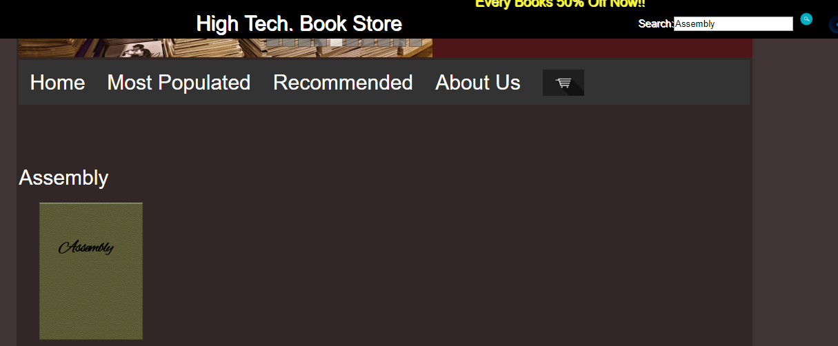

Search for the book “Assembly”

1. Site map:It can navigate users to different pages of the website and save users’ times.It is convenient and user-friendly.



Site map to different pages

1. Different validation:There are different validation when users log in,sign up,click on the cart and add to the cart.If users enter wrong information,alert message will be show to remind users.It avoid users enter incorrect information and cause garbage-in-garbage-out with wrong output.It can make the function process correctly.

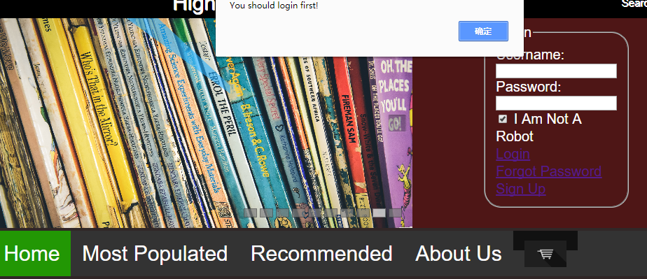

Warning message show up when click the cart without log in

6.Have image description:The images and buttons have description when the mouse move on them.It can help the people with visually-disabled and more user-friendly.

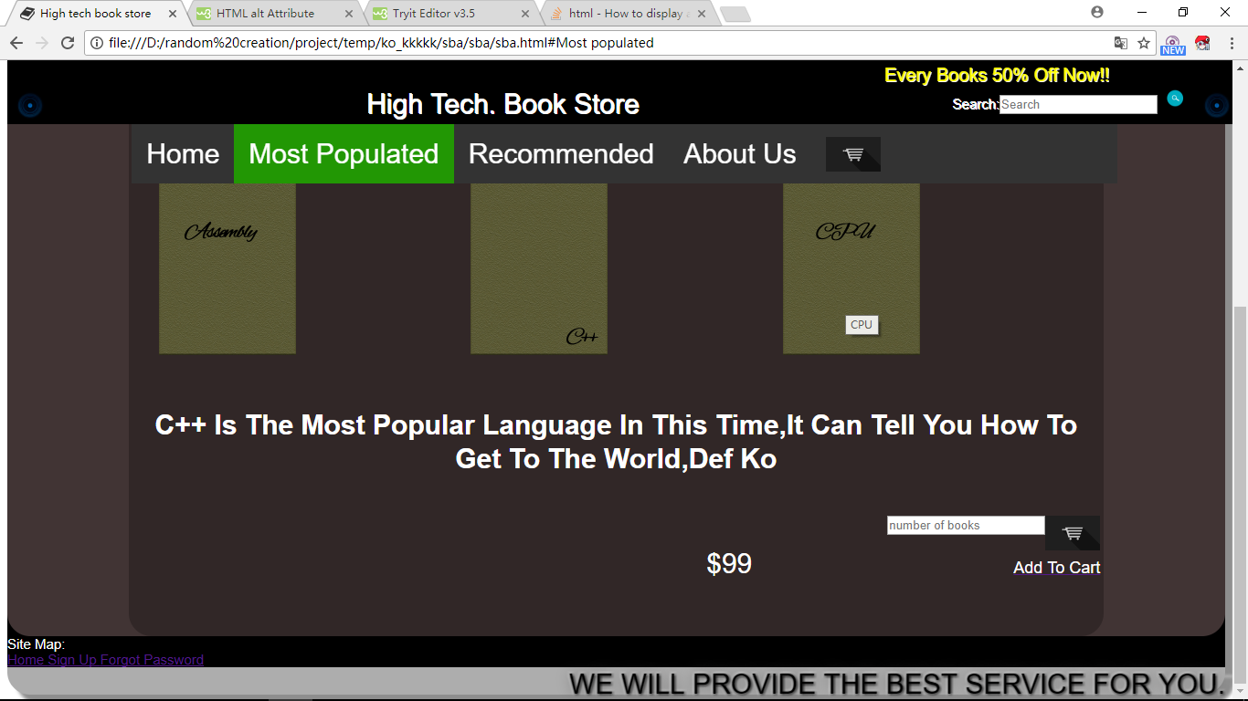

Image description

In general,the pros of the website is user-friendly with time-conserving and convenient,clear layout.

### Cons

1. Not printer-friendly:The website do not have a printed version which can fit into a A4 size paper,it will return a strange layout when the page being printed out.

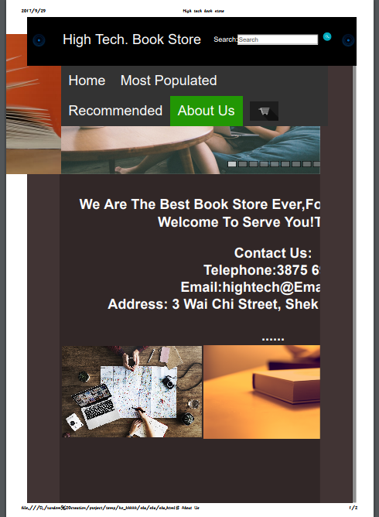

Strange layout when printed out

1. Do not have different layout with different screen size:Current layout can just perform well under aspect ratio 16:9 with large screen.While it can not adapt to Mobile phone screen.

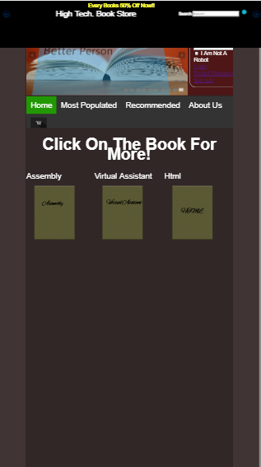

Screen layout in Iphone 5

1. Do not have multiple language:There is only English in the website.It may not convenient to the people using different language.
2. Cannot adjust front size:There is only default front size in the website.Users cannot adjust the front size,it may not convenient to elderly which require larger front size.

# Multimedia Element:

### Image

The website have many images in different pages in order to attract users’ attention.In addition,there is a slide show the images of bookstore.It will show the promotion information of the book store with sliding effect automatically and can attract customer efficiently.

All the images are in JPEG format,which are small in file size with compression.It can be loaded fast even under slow network speed.Also,there are descriptions of the image.The users can still know the images even under slow network speed.

# Key Factors of a Good Website

### Clarity

The layout of the website is clear with instructions and well readability.The layout is with dark-colored background and light-colored characters,therefore the words are clear for users to read.Also,the button and input area are clear stated,users can know what to input and the uses of the buttons immediately.For example,the icon of “Shopping cart” is a cart,which is well-known and users can recognize it.



Cart icon

### Usability

All the functions in the shopping cart can work well,including the function of “add to cart”, “save selection”, “cleared selections”, “checkout” and calculation of the price of the books.Users can add the books into the cart,then save their selections.When they log in again,their saved selections will appears and they can check it by entering the shopping cart

Users can also cleared all the selections by clicking the “Clear” button.Finally,when users click “checkout”,the website will calculate the total price according to the quantities entered by users.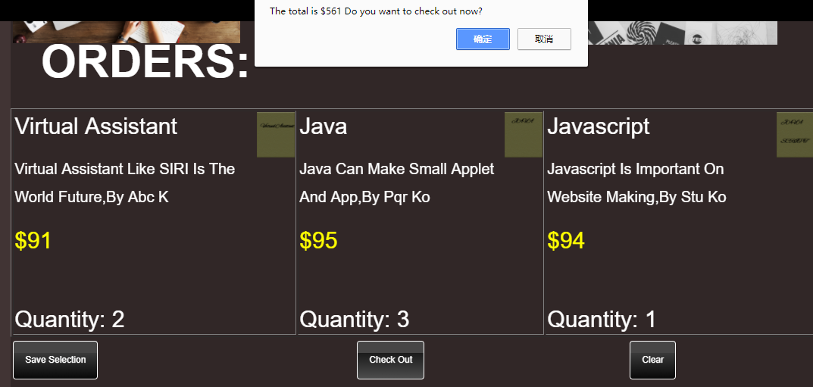

Calculation of price

### Accessibility

The images and the buttons in the website have description,which can make the people who is visually disabled or need to use screen reader to know the content of the website.It can make the website have high accessibility.In addition,the website do not use many types of color,it can helps those who is color-blind not to be puzzled when they are using the website.

### Navigation

The website have well navigation that make the users can easily find the books they want in different criteria.It has navigation bar which has different criteria to choose and site map to go to different pages of the website.Therefore,users can easy to navigate to different pages.

# Improvement of website

### Function

In previous version of the website,the function of shopping cart cannot all functioned well.All the functions has been improved and can work well now.Including the function of “add to cart”,“saved selections”,”cleared selections” and calculation of the total price.

### Search bar

The search bar cannot be functioned in previous version and now can functioned well.Users can just enter the book name they want to search.If website find the book,it will display and can available for add to cart.If cannot find the book,it will display the message that cannot search the book.

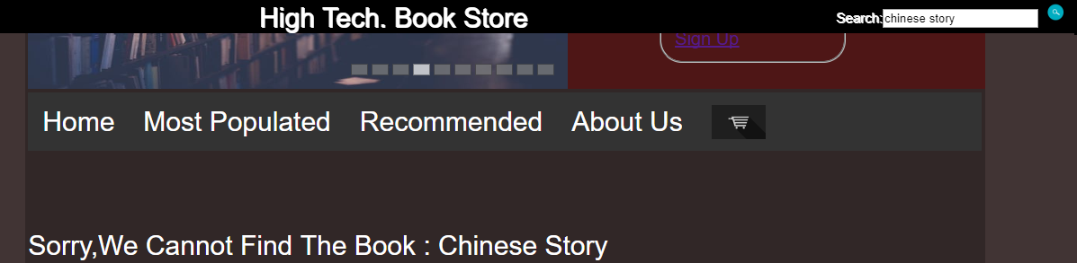

Message that cannot find the book

### Site map

There is no site map in the previous version of website.Site map is added to navigate users to different web page more convenient.It can navigate to “Homepage”, “Sign up page” and “Forgot Password Page”.It can make the website more users-friendly.

### Bugs

There are some minor bugs in the previous version such as wrong navigation.The bugs is now fixed.

# Test and Evaluation

### Function

|  |  |  |  |
| --- | --- | --- | --- |
| **Test object** | **Problems** | **Reasons** | **Solutions** |
| Add to cart function | Cannot show the appropriate books | Logical error when setting the table to display books | Change the methods to display books |
| Save Selections function #1 | Clear local storage when go to home page | Call the function of clear selections in wrong place | Delete the clear function in that place |
| Save Selections function#2 | Cannot get to the shopping cart as the item numbers is zero | Do not update the item numbers when users log in again | Update the item number when detect local storage |
| Calculation of total price#1 | Do not have correct output of total price | Do not multiple the price of the appropriate books | Add the multiple of books with a loop |
| Calculation of total price#2 | The output do not match the books and its price | Problems causes by add to cart function | Fixed the add to cart problems |

### Search Bar

|  |  |  |  |
| --- | --- | --- | --- |
| **Test object** | **Problems** | **Reasons** | **Solutions** |
| Recognize search value#1 | Cannot find the function “search” | The function have same name with another function in JavaScript | Change the name of the function |
| Recognize search value#2 | Cannot recognize search value | Cannot recognize the form name and process | Change the methods of “OnClick” and set it inside the form |
| Display the message that do not find the book | Display nothings when do not find the book | Set the display to empty and overwrite the original display | Delete the empty display |
| Display the book | Display other two book in the meanwhile | The value of two books is set and display them | Set the value of two books to empty |

### Site map

|  |  |  |  |
| --- | --- | --- | --- |
| **Test object** | **Problems** | **Reasons** | **Solutions** |
| Go to other pages | Cannot find the pages | The location of files are wrong | Fixed the location of files |